Plan for my final project

Name: | <put your name here!>

A description of the project that I want to create:
I want to make a multiplayer game with two bats and lots of insects. The bats each have health and they collect as many insects as they can to get healthier and to win. They get points for every insect which they put in their store. They can steal each others insects too. And if they run out of insects they starve and their health goes to zero. The winner is the bat with the most insects after the game ends. The game only lasts 5 mins. If one bat starves before the game is over the other bat wins.
The steps I will take to develop my project:
- I will make a scrolling stage with caves and stars. It is night time in my stage. I will play cool music.
- I will make varuiables called health and insect store and I will show them.
- I will make two bat sprites. They will fly around.
- I will make 10 insect sprites. They will fly around too. When the bat touches them the insects will hide for 60 seconds and the bats health and insect store will increase.
- I will make a sprite for the game ending with victory music.
The resources (e.g. people, sample projects) I already have to develop my project:
- I found bat sprites that can fly in Week 5 folder on Dropbox (called bat demo)
- I have a stage I can use from my other projects
The resources (e.g. people, sample projects) I might need to develop my project:
- I will need my friends at Coderdojo to help me get my project working!
- I will need my friends to test my game.

Sketches of my final project

Name:

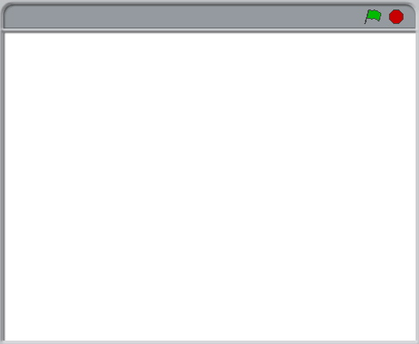
What’s happening?  What are the important elements? |  | What’s happening?  What are the important elements?
What’s happening?  What are the important elements? |  | What’s happening?  What are the important elements?

Developed by the ScratchEd team and released under a Creative Commons license.

